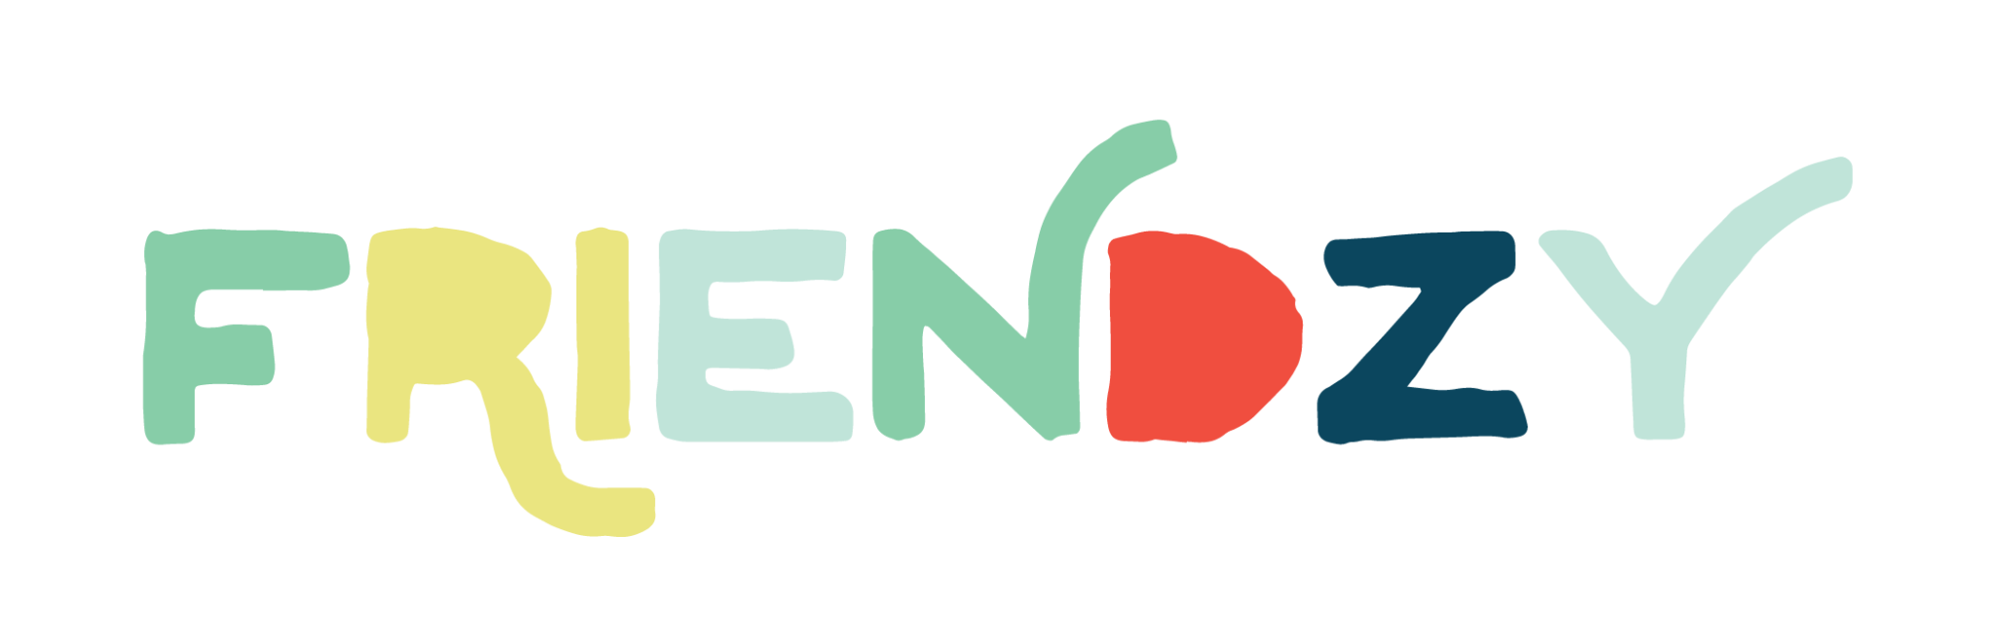

FRIENDZY | Program Alignment with ESEA Title I Part A, for Public Schools

Title I, Part A: Improving Basic Programs Operated by Local Education Agencies

PURPOSE
To help ensure that all children meet challenging state academic standards by providing additional funding to schools with a high percentage of low-income and at-risk students.

ELEMENTS OF FRIENDZY THAT TITLE I-PART A MAY BE ALLOWABLE TO FUND
All Friendzy character education program elements fall under allowable uses of section 1114b & 1115a “implementation of a school-wide tiered model to prevent and address problem behavior and early intervention services.”

Friendzy professional development and parent resource consultation services fall under allowable uses of section 1115d professional development necessary to assist teachers, specialized instructional support personnel, other staff, and parents in identifying and meeting the comprehensive needs of eligible children.”

Program Overview

The Friendzy curriculum is a character-building program that is designed around the 5 Core Competencies of Character Development: self-awareness, self-management, social awareness, relationship skills, and responsible decision-making.

Friendzy equips educators with the training, assessment tools and curriculum needed to proactively teach the character-building skills proven to set students up for academic and social success in the classroom and beyond.

Friendzy provides educators and students with activities and standards of practice for supporting students in the development of self-awareness, self-management, social awareness, relationship skills, and responsible decision-making. In this way, Friendzy supports the kinds of responses to students’ needs that can positively impact climate and culture in a community.

Friendzy provides resources to align and support the school-parent-community relationship and create opportunities for growth, learning, belonging an community connection. Many of these resources are available in Spanish, supporting student-parent-school relationships of Spanish speaking ELL students.

Stakeholder Engagement: Friendzy involves students, school leaders, teachers, parents, and the community. It is a collaborative, relationship-based program that will impact the collective efficacy of the school community. Monthly Parent/Guardian letters, Social media ready materials for communication to connect the parent community to the work that students are doing in the classroom, conversations starters for families, all of these are intended to connect school to home.

Program Implementation
The Friendzy program will be implemented using a combination of Professional Development resources and Classroom Resources accessible on the Friendzy portal.

Professional Learning Resource Portal Access for all faculty
The Friendzy online resource portal includes access to 20 hours of ideologically neutral, evidence-informed, and research-based guided character education sessions and activities alongside additional virtual PD opportunities and personalized consultation to build a character education professional learning plan that fits the needs of each school community based on conversation, needs assessments and web assessment reporting (our direct assessment with climate and culture add-on that we include with our professional development package for all enrolled students).
The Professional Development page gives a high-level list of the current sessions schools have access to on our portal. We update our sessions regularly. All sessions are led by highly qualified educators, psychologists, and character education experts.

Friendzy Online Resource Portal—Classroom Resources
The Friendzy online resource portal includes volume-based classroom resources, including:
- Lesson Slideshows
- Downloadable student worksheets
- Video content
- Daily Reinforcement & Friendzy signature practices library
- Administrative portal included consultation on school-wide, classroom-based based and parent-specific implementation guidance
The Purchase of these resources allows for immediate one-time use/download access for each registered teacher account.

The Friendzy program guides teachers in the use of Emotions Charts, Object lessons, Games, Brain science, Daily Reinforcements and other classroom practices that provide hands-on experiences where students can engage with explicit skills in “Character-building development and academic growth, including interventions that support positive relationships, resilience, self-control, empathy, persistence, and other aspects of positive character education.” (BCSGC)
Specifically, Friendzy addresses skills in the following competencies:
- Self-Awareness
Explicit Skills: identifying emotions, self-perception, identity, recognizing strengths, sense of self-confidence, and self-efficacy
Self-awareness is a student’s ability to name and understand their emotions. If they struggle to do so, it can cause dysregulation and create learning barriers - just think back to a time when you felt stressed and how hard it was to do a simple task.
- Self-Management
Explicit Skills: impulse control, stress management, self-discipline, self-motivation, perseverance, goal-setting, organizational skills
Now that students can identify how they feel, can they manage their emotions? When we notice students struggling to manage themselves, often it’s because they aren’t able to articulate what they need.
Responsible Decision Making
Explicit Skills: identifying problems, analyzing situations, solving problems, reflecting, evaluating, and taking ethical responsibility
With young students, their frontal lobes (part of the brain that is responsible for executive functions) are not fully developed until their mid-20s. This means that your students are making decisions with the emotional part of their brains!
Decision-making might look different in younger and older students. In younger students, they might be deciding on which adult to ask for help and in older students, they might be deciding on whether they should eat a Snickers bar or a well-balanced meal right before a test.
- Social Awareness
Explicit Skills: perspective-taking, empathy, appreciating diversity, respect for others
Kids can begin to feel shame as early as kindergarten. Because Friendzy is a strengths-based program, we want to create a space where students can celebrate unique strengths and cultures.
- Relationship Skills
Explicit Skills: communication, social engagement, building relationships, working cooperatively, resolving conflict, helping, seeking help
Relationship skills are like the tip of an iceberg. To build and form positive relationships, we need the other 4 competencies (what you usually don’t see on the surface because it’s under the water), so Friendzy must teach all core competencies holistically
This framework is intended to support the climate and culture needs of all students and is particularly inclusive of ELLs/SWD, offering opportunities for oral language practice, collaboration with peers, and the building of social perspective-taking and empathy practices within the classroom and school community.

Resources to support your application:
- Supporting English Learners and Students With Disabilities

Measurement of Program Effectiveness
The Friendzy program will be evaluated using an online assessment that measures student growth across five core competencies. This two-point tool captures both a baseline and post-program results to show measurable progress.

The efficacy of this tool can be reviewed in the research provided below. Research on the SELweb assessment (https://xsel-labs.com/assessments/selweb/) has been conducted and can be viewed here:
Research-Based IES Research K-6 grade
https://ies.ed.gov/funding/grantsearch/details.asp?ID=1854
Research-Based IES Research Middle School
https://ies.ed.gov/funding/grantsearch/details.asp?ID=4450

